Maturity Grading of Jujube for Industrial Applications Harnessing Deep Learning
Atif Mahmood ^{1,*}, Amod Kumar Tiwari ², Sanjay Kumar Singh ³, Mohd. Mohsin Ali ⁴
^{1,2,4} Department of Computer Science and Engineering, Dr. APJ Abdul Kalam Technical University, Lucknow, India. ³ Department of Computer Application, Dr. APJ Abdul Kalam Technical University, Lucknow, India.
*Corresponding author e-mail: atif.mahmood@recsonbhadra.ac.in
ORCiD ID: https://orcid.org/0000-0002-8220-1708

Abstract: Jujube is one of the popular fruits that possess high nutritional components and have economic value. Grading of jujube is a post-harvest process applied in the fruit industry for the tasks like fruit quality check, fruit species identification, price labelling, edibility duration estimation, safety, etc. This research investigates into the suggested 7-layer CNN model and two classical models (i.e., VGG16 and AlexNet) for grading jujube fruits according to their stages of maturity. Primarily, jujube of four different maturity grades was identified on the field and collected from the field manually and their images were captured through a machine vision system. Further, image pre-processing and augmentation were performed to get the training/testing-ready dataset. Finally, a 7-layer CNN model was deployed and grading performance was examined over the original and augmented dataset using performance metrics of precision, sensitivity, and F1-measure. Furthermore, the model's classification accuracy was compared to that of classical models, where the proposed model surmounts both the classical models. Results reveal that the proposed model attained a high grading accuracy of 99.44% and 97.53% over the augmented and original dataset respectively. Also, the computation time and training parameters count were reduced to almost one-tenth and one-third of that of VGG16 and AlexNet models. Results advocate that the classical model could be replaced with the proposed models and can be further investigated for other fruits for better classification accuracy, reduced parameters and reduced computational time.
Keywords: AlexNet, CNN, Grading, Jujube, Maturity, and VGG16
Abbreviations
ML | Machine Learning | DT | Decision Tree
DL | Deep Learning | NB | Naive Bayes
CNN | Convolution Neural Network | VGG16 | Visual geometry group (16 Layers)
MVS | Machine Vision System | ANN | Artificial Neural Network
PCA | Principal Component Analysis | KNN | K-Nearest Neighbour
LDA | Linear Discriminant Analysis | SVM/R | Support Vector Machine/Regression
AlexNet | Alex Network
- Introduction
India is the next largest producer of jujube following China worldwide. In India, around 90 varieties of jujube are cultivated mainly in the provinces of Uttar Pradesh, Haryana, Bihar, Chhattisgarh, Andhra Pradesh, Punjab, Rajasthan, Madhya Pradesh, Gujrat, Maharashtra, West Bengal, and Tamil Nadu [1]. Conventionally, jujube can be consumed directly as a natural pulp or in the form of confectionary recipes like candy, cakes, compotes, snacks, bread, jam, jelly, drinks (i.e., juice, tea, vinegar, and liquor) etc [2]. Jujube has a luscious flavour and several effective herbal remedy constituents. Jujube possesses anti-bacterial, anti-fungal, antioxidant, cardiotonic, anti-ulcer, anti-spastic and wound healing properties. It potentially improves muscular firmness, weight gain, and stamina [3]. That’s why fruits and their seeds are harnessed for preparing traditional medicines. Due to the vast functional derivatives of jujube, researchers and food industries have paid attention to jujube fruits in the recent decades. It is vital to identify the distinct maturity stages of jujube to prepare various functional food items and remedies. Therefore, the grading of jujube needs to be done through an automated system as manual grading is time-consuming, sometimes fallacious due to less expertise and expensive too. Grading of jujube based on their maturity stages can be done through a MVS and CNN is a non-destructive method [4] that could be harnessed in the food industry for post-harvest identification and classification purposes.
The maturity stages of jujube fruits can be identified through their peal colour. In this research, we have considered 4 stages of jujube. Where the first stage is immature or unripe jujube which appears to be of green colour with a smooth surface. While the next three are mature or ripen stages with varying colours. Primarily mature stage-1 is edible jujube which appears to be of light yellow or golden colour; mature stage-2 is also edible jujube but appears to be partially red and yellow; Thereafter final stage is over ripen stage and is edible before its skin gets wrinkled. Figure1 depicts the four maturity grades of jujube. In this work, we have proposed a non-destructive MVS using 7-layer CNN model for jujube grading based on four maturity stages. The proposed model was examined over the collected original jujube images and augmented jujube images. Further performances of the model were compared with the VGG16 and AlexNet models for the pre-trained and from-scratch variants.
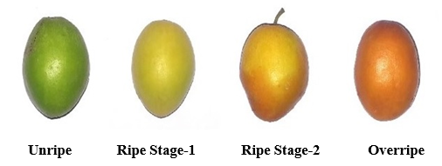
Figure 1. Maturity grades of jujube fruits
Within the ambit of this research,
- An MVS was installed to capture the jujube images of four maturity stages and store them in digital media.
- An efficient and effective 7-layer CNN model was developed for the grading of jujube over an original and augmented dataset.
- The Pre-trained and from scratch models of two successful CNN architectures (i.e., VGG16 and AlexNet) were deployed to investigate the jujube grading performance over the original and augmented jujube dataset.
- The grading of jujube into four maturity stages was achieved with a high success rate and the least computation time, training epochs as well as the least training parameters harnessing the proposed model.
The leading contributions of the research are underlined as follows,
- Primarily, dataset collection and organization were performed to produce a real dataset for the training and testing purpose for the four maturity grades of jujube.
- Secondly, an efficient and reliable jujube grading model compared to the other two classical models was achieved.
- Finally, in the food processing and packaging industries grading system could be adapted to perform quick grading and pricing of jujube accordingly.

Following to current section, the upcoming portions of the work are organised as:
The “related research” section discusses recent articles possessing DL methods for fruit grading. Next section, “materials and proposed system” outline the dataset collection and organisation steps as well as the detailed working of the proposed model for the grading of jujube fruits. The “discussion of the findings” section presents the results and detailed discussion of the examined models over the original and augmented dataset. Finally, the Conclusion, limitations and future directions of the presented work are discussed in the last section.
- Related Research
Crop maturity identification and assortment come under the realm of crop quality evaluation, which is a sub-category of crop management in the agricultural system [5][6]. Various works have been conducted for the identification and classification of fruit's maturity or ripeness leveraging ML and DL techniques. In the current section, we have addressed some of the recently published works for several fruits. In the article [7] authors applied the two CNN models (i.e., pre-trained MobileNet V2 and pre-trained NASNet Mobile) for the classification of bananas into four ripeness classes. The dataset used for the experimental work was obtained from other literary works which constitute a total of 436 banana images. Results report that MobileNetV2 outperform the other model by achieving an accuracy of 96.18%. Another article [8] proposed a MVS employing ANN to identify the banana ripeness level based on spots, texture, and colour features. A dataset of 300 images was prepared for the 4 ripening classes of banana and the achievement of the model was compared with models such as SVM, NB, KNN, DT, and discriminant analysis classifier. Overall identification accuracy of 100% was noticed for the over-ripen and green bananas, while mid-ripen and yellowish-green classes achieved 97.75% accuracy. The authors of [9] developed the MVS to recognise mango fruit maturity and quality using exact-days-to-rot and some quality traits. A SVR algorithm and a Multi-Attribute Decision Making (MADM) system, respectively, were used to predict maturity and estimate quality grading. Furthermore, a fuzzy incremental training algorithm with a precision of around 87% was used for grading. Article [10], also presents the grading system for mango using the deep learning concept. An ultra-lightweight model based on SqueezeNet architecture was introduced which achieves an average accuracy of 97.37% over the training samples of 234 mango images belonging to 4 grades. The literature [11] & [12] discusses the ripeness of avocado fruits. The MVS utilizing two machine learning methods (i.e., ANN and SVR) was deployed in [11] for determining the firmness of avocados based on colour features (i.e., YUV and L*a*b*). The evaluation of avocado was performed over matrices such as determination coefficient (R²), the root mean squared error (RMSE), and ratio of performance to deviation (RPD), with ANN outperforming the SVR. In literature [12], authors developed a system employing a hyperspectral camera and CNN model for classifying the avocado and kiwi fruits into three ripeness classes (i.e., unripe, ripe, and overripe). The proposed classifier results were superb for the avocado fruits while the classification accuracy for the kiwi fruits was found to be good. Authors of the next study [13] developed a system to classify durian into three ripeness classes based on its aroma. The gas sensor was used to generate the pattern for distinct ripeness levels of durian and ANN to discriminate the durian with a precision of 94.5%. The maturity categorization of papaya harnessing ML and DL approach was reported in the literature [14]. The ML-based approach uses GLCM, HOG, and LBP features for the discrimination of papaya, where KNN with HOG achieved an accuracy of 100% with minimum training time. While the DL-based approach was tested for 7 different architectures, where VGG16 reports 100% accuracy with minimum training time. Two cutting-edge pre-trained deep learning techniques were investigated in research [15] for the division of jujube fruits into three classes of ripeness. Using the original and enhanced datasets, both models were trained and evaluated. The VGG16 model over the supplemented dataset reportedly attained a high accuracy of 99.17%, according to experimental results. Furthermore paper [16], determines the ripeness of white and blackberries in five grades based on aromatic volatiles of berries. An electronic nose as a sensor was used with ANN, PCA, and LDA to perform the grading. ANN performs well, with precision of 88.3% for white berries and 100% for black berries. The authors of article [17], developed a system for grading and sorting dragon fruit applying SVM, ANN, and CNN based on colour, weight, size, shape, and diseases of fruit. The performance of CNN was found to be effective as compared to SVM and ANN models. A robust DL model based on YOLOv3-tiny ANN architecture was implemented in the research [18] for identifying and categorizing coffee fruits into 3-maturity classes. The implemented method classifies the coffee fruits into overripe, ripe and unripe categories achieving a mean precision of 80%, 85%, and 86% respectively.
- Materials and Proposed System
3.1 Image Acquisition and pre-processing
The jujube samples used for the experimental purpose were collected from the jujube trees in the REC campus of Sonbhadra city of Uttar Pradesh province, India. The images were captured through an AI-based high-definition camera cell phone by placing the subject over the white paper from a distance of 15 cm over the top. It took around 3 months to collect all four maturity grades of jujube, which include 146 unripe, 141 ripe stage-1, 131 ripe stage-2, and 123 overripe jujube images. In order to minimize the time needed for model training, captured images were also pre-processed by manually clipping the region of interest before being resized to a predetermined size of 300*300. As captured images were having varying resolutions and sizes, therefore python code was implemented employing the OpenCV framework to resize the images to the desired size [19].
3.2 Data Augmentation
In DL, a sufficiently large dataset is required to train the network. As we have a limited amount of collected dataset that may lead to a problem of overfitting. Therefore, to avoid the problem of overfitting we applied data augmentation [20]. Data augmentation techniques aim to enhance the count of samples which helps to alleviate the overfitting issue to some extent and raised the generalization ability of the model [21]. Five augmentation methods including cropping, flipping, scaling, rotation, and zooming were applied over the original jujube dataset to generate a total of 5949 jujube images. The original and augmented dataset distribution for the four maturity grades of jujube is exhibited in figure 2.

Figure 2. Dataset distribution
3.3 Proposed System
The overall workflow for jujube grading consists of several phases. The whole process begins with manual analysis and collection of four jujube grades from the jujube tree, in addition to this jujube image acquisition was performed utilizing MVS which is further followed by image pre-processing and augmentation tasks. Eventually, classification models (i.e., proposed model, pre-trained and from scratch VGG16 [23] and AlexNet [22]) were trained and validated over the original and augmented datasets to discriminate the jujube into maturity grades. The overall workflow framework for the jujube grading is exhibited in figure 3.
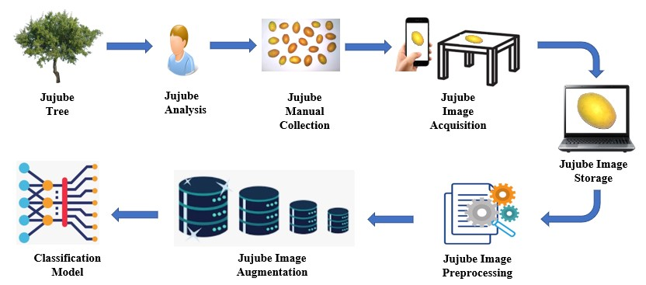
Figure 3. Workflow framework for jujube grading
The proposed classification model consists of 7 layers, where the first four layers are convolutional and the last three are dense layers. The first, third, and fourth convolution layers are each concatenated using max-pooling, then a dropout layer is added on top. The intervening dense layer is also concatenated with the dropout layer. All the layers either convolution or dense use a ReLu activation function except the final dense layer which utilizes the softmax activation function to categorize the jujube visuals into four maturity grades. In addition, the Adam optimizer was used to improve the model performance, figure 4 depicts the proposed model's architecture. The overall investigation of the model performance for the original and augmented dataset was conducted in two aspects. Initially, an experiment was determined to assess the efficacy of the suggested model based on outcome accuracy, precision, sensitivity, and F1 score, as well as the confusion matrices. Where accuracy is used to predict the model's success. Precision is a metric that indicates how many correct positive predictions were made. It indicates the probability that a positively predicted situation is actually positive. A sensitivity is a measure that shows the percentage of accurate positive predictions among all potential positive forecasts. The harmonic mean of the precision and sensitivity values is the F1-score value.
Accuracy = Correctly predicted jujube images / Total jujube images (i)
Precision = TP/((TP+FP)) (ii)
Sensitivity = TP/((TP+FN)) (iii)
F1-Score = 2* (Precision * Sensitivity) / (Precision +Sensitivity) (iv)
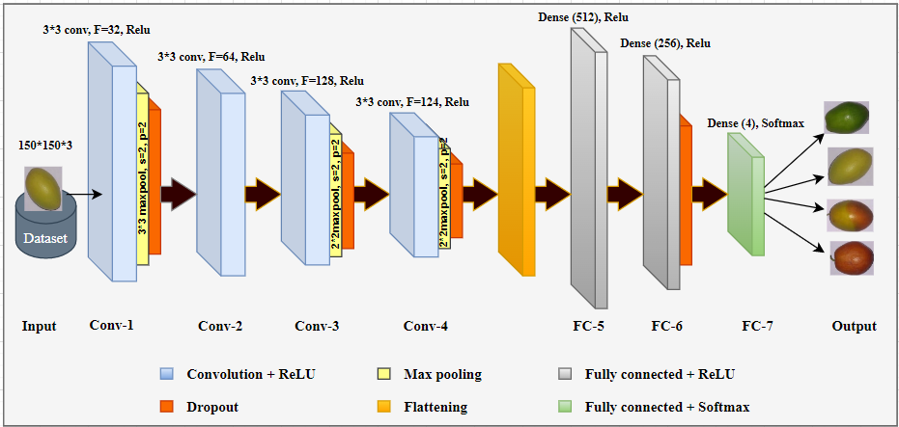
Figure 4. The proposed 7-Layer CNN model's architecture
The next experiment was performed to determine the effectiveness of the suggested model compared to classical models on account of training parameters count, the number of epochs, success rate, and elapsed training time. To perform the experiments, both datasets were subdivided into training/testing splits (70% and 30%). To compare the model performance, we trained VGG16 and AlexNet models as pre-trained as well as from scratch. Pre-trained AlexNet [15] consisting of three-dense layers and five-convolutional layers. Each convolutional layer possesses varying kernel size and strides and by default input images of size 227*227*3 are employed to the first convolutional layer for the training/testing purpose. Additional layers connected to several dense and convolution layers include ReLu, max-pooling, LRN, and dropouts. The pre-trained VGG16 [15] consists of 13 convolutional layers and 3-dense layers. Here, in contrast to AlexNet, all the convolutional layers of VGG16 possess fixed kernel size, stride, and padding and by default it operates over images of size 224*224*3. Again, ReLu and max-pooling are additional layers connected to many of the dense and convolution layers. For both, the pre-trained model’s weights and learning rates are kept unchanged while the last dense layer was replaced with 4 neurons as per our case. Similarly, we trained both the model from scratch with little adjustment such as keeping learning rate to .003, applying dropout of 20%, and using Adam optimizer to both the models.
- Discussion of the Findings
The baseline system configuration for the experimental work is comprised of a 12-GB RAM and a Tesla-K80 GPU running over Google Colab, a Jupyter notebook environment which is cloud-based. All the experimental training/testing of the networks was performed for 50 epochs as not much enhancement in accuracy was observed over the next 50 epochs. Initially, training/testing was performed with the proposed 7-layer CNN over the original and augmented dataset. The distinct measures examined for the performance of the model are accuracy (correctness), precision, sensitivity (recall), and F1-measure as well as the confusion matrices. The highest success rate reported over the original and augmented datasets were 97.53% (i.e., error of 2.47%) and 99.44% (i.e., error of 0.56%) respectively. The accuracy curves and loss curves for both datasets were depicted in figure 5 and figure 6. For augmented dataset accuracy and loss, curves are smoother due to the large dataset that leads to sufficient training of the model. Further figure 7 exhibits the precision, sensitivity, and F1-measure for all four jujube maturity grades. Over original dataset precision, sensitivity, and F1-measure for the overripe grade reported 100% success and for the remaining grades these value ranges in between 93%-100%. On the other hand, over the augmented dataset precision, sensitivity, and F1-measure for overripe and ripe stage-2 grades reported 100% success, while ripe stage-1 and unripe grades performance metrices are approaching to 99% or 100%.

- (b)
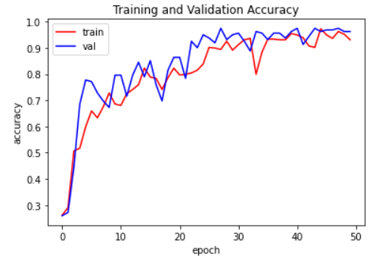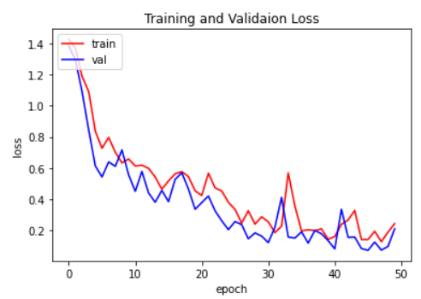
Figure 5. (a) Training/validation accuracy curve and (b) loss curve of the proposed model over the original dataset

- (b)
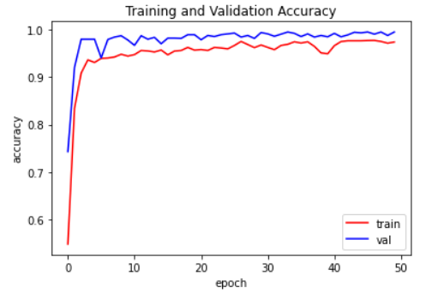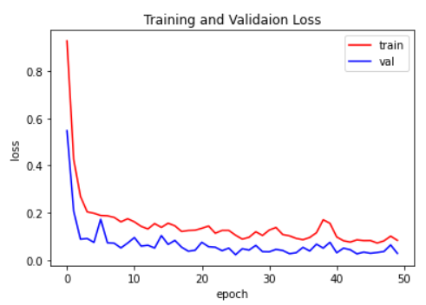
Figure 6. (a) Training/validation accuracy curve and (b) loss curve of the proposed model over an augmented dataset

- (b)

Figure 7. Performance metrics of the proposed model over (a) original dataset and (b) augmented dataset

In figure 8, the confusion matrix for the proposed model over both datasets is presented. We can infer that unripe and ripe stage-2 instances are bit challenging to classify without confusion, while ripe stage-1 and overripe grades are correctly classified without any confusion over the original dataset in figure 8 (a). Similarly, ripe stage-1 instances are bit daunting to classify without confusion to that of ripe stage-2 and unripe instances, while the overripe grade is correctly classified over the augmented dataset as depicted in figure 8 (b). Hence, we can conclude that overripe instances for both datasets are correctly classified without confusion. At the same time, unripe and ripe stage-2 classifications are improved over the augmented dataset but degraded for the ripe stage-1. We believe that the prime cause of misclassifications is due to texture similarity in a few samples of unripe, ripe stage-1, and ripe stage-2 grades along with a limited dataset.
- (b)
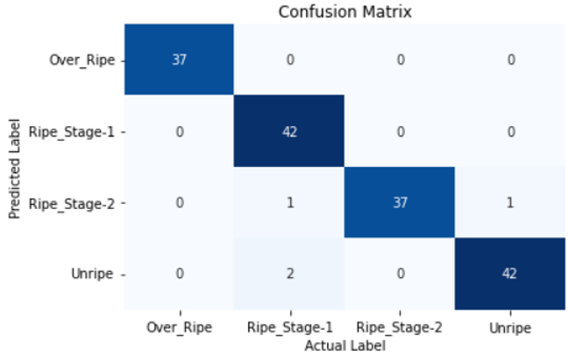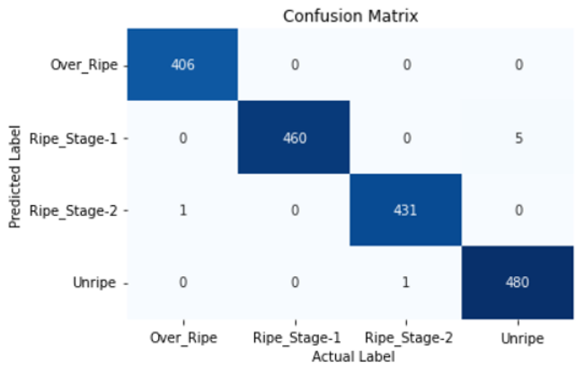
Figure 8. Confusion matrix of the testing dataset for the proposed model over (a) original dataset and (b) augmented dataset

Further, another experiment was carried out to compare the presented model's performance with two classical CNN models. The Classical models considered for the experiment are VGG16 and AlexNet as pre-trained as well as from scratch. Results revealed the advantage of using a pre-trained model over the scratch model for the classification tasks. The success rate of pre-trained classical models is higher than that of their model built from scratch, as exhibited in table 1. Each model's performance on the expanded dataset is shown to be superior to that on the original dataset, this may be due to the trivial training of models in the case of the original dataset. Although in one of the case (i.e., AlexNet model from scratch) performance appears to be almost the same for the original (i.e., 90.74%) and augmented (i.e., 90.83%) dataset. Table 1 depicts the model's performance comparison. The overall performance of models in perspective to the number of parameters, classification success rate, number of epochs, and training time is discussed below.
# of parameters: The total number of training parameters is considered to be a factor to differentiate the model's effectiveness. As the model parameter is directly proportional to the training time. Therefore, it is emphasized to reduce the parameters of the models. In our case, all three models possess huge training parameters. According to the results, the proposed model has nearly one-tenth and one-third the training parameters of the VGG16 and AlexNet models, respectively.
Success rate: It is the correct classification percentage of the four maturity grades of jujube. The proposed model outperformed the pre-trained and from-scratch classical models by achieving a success rate of 97.53% (i.e., the same as that of pre-trained VGG16) and 99.44% over the original and augmented dataset respectively. Pre-trained VGG16 model reports the next successful model achieving a 98.83% success rate followed by the pre-trained AlexNet achieving 96.17% over the augmented dataset.
Computational time: It is the elapsed average time per epoch during the model training. As the proposed model possesses a lesser number of parameters as compared to classical models, this leads to the least training time of the proposed model 25 seconds and 252 seconds over original and augmented datasets respectively. On contrary to this from scratch VGG16 reports the maximum training time of 7463 seconds and 787 seconds over augmented and original datasets respectively.
# of epochs: This is the number of training iterations that results in the greatest accuracy. Again, suggested model achieved the best accuracy at just 28 epochs and 34 epochs over the original and enhanced dataset. While for the classical model best accuracy was achieved after 40 epochs in most of the cases.
Table 1. Model’s performance measures
Models | Dataset type | # of parameters | Success Rate (%) | # of Epochs | computational time (sec.)
7-Layer CNN | Original | 6,717,888 | 97.53 | 28 | 25
7-Layer CNN | Augmented | 6,717,888 | 99.44 | 34 | 252
AlexNet (Pre-Trained) | Original | 22,765,316 | 94.25 | 37 | 88
AlexNet (Pre-Trained) | Augmented | 22,765,316 | 96.17 | 41 | 797
AlexNet (From Scratch) | Original | 22,765,316 | 90.74 | 43 | 52
AlexNet (From Scratch) | Augmented | 22,765,316 | 90.83 | 45 | 518
VGG16 (Pre-Trained) | Original | 68,199,236 | 97.53 | 46 | 276
VGG16 (Pre-Trained) | Augmented | 68,199,236 | 98.83 | 39 | 2847
VGG16 (From Scratch) | Original | 68,199,236 | 93.27 | 42 | 787
VGG16 (From Scratch) | Augmented | 68,199,236 | 95.43 | 35 | 7463
- Conclusions
The identification of maturity grades of jujube is paramount in the fruit industry, functional food production industries and pharmaceutical industry. This research examines the performance of proposed CNN models for the grading of jujube maturity into four classes and compares them with the classical models to depict the sublime model in terms of accuracy, the number of parameters, epochs and computational time. After a thorough investigation of the models, it was discovered that the proposed model transcends both classical models in all aspects for both the original and augmented datasets. However, there is some downside of this research which need to be investigated. The investigation relies upon a single view of the jujube image and the outer appearance of the jujube. In the future multi-view image capturing system could be employed for the model training/testing. In addition, two more classes of jujube (i.e., defective and dried jujube) could be added to the existing dataset. On the improved 6-class dataset, the suggested model will be examined and to be compared against other cutting-edge models.
Acknowledgements
The authors would like to express their heartfelt gratitude to the Director and Dean of the Research Centre at Rajkiya Engineering College, Sonbhadra for supporting the work and providing the necessary resources for the accomplishment of this research work.
Declaration of Competing Interests
The authors declare that they have no known competing financial interests or personal relationships that could have appeared to influence the work reported in this paper.
Data Availability
The datasets generated during and/or analysed during the current study are available from the corresponding author on reasonable request.
References
[1] J. S. Bal, “Development and production of Indian jujube (ber) in India,” Acta Hortic., vol. 1116, pp. 15–22, 2016, doi: 10.17660/ActaHortic.2016.1116.3.
[2] A. K. Rashwan, N. Karim, M. Rezaul, I. Shishir, T. Bao, and Y. Lu, “Jujube fruit : A potential nutritious fruit for the development of functional food products,” J. Funct. Foods, vol. 75, no. 866, p. 104205, 2020, doi: 10.1016/j.jff.2020.104205.
[3] S. Pareek, “Nutritional composition of jujube fruit,” Emirates J. Food Agric., vol. 25, no. 6, pp. 463–470, 2013, doi: 10.9755/ejfa.v2516.15552.
[4] S. Bureau, “The Use of Non-destructive Methods to Analyse Fruit Quality,” 2009.
[5] A. Mahmood, A. K. Tiwari, S. K. Singh, and S. S. Udmale, “Contemporary machine learning applications in agriculture: Quo Vadis?,” Concurr. Comput. Pract. Exp., no. February, 2022, doi: 10.1002/cpe.6940.
[6] K. G. Liakos, P. Busato, D. Moshou, S. Pearson, and D. Bochtis, “Machine learning in agriculture: A review,” Sensors (Switzerland), vol. 18, no. 8, pp. 1–29, 2018, doi: 10.3390/s18082674.
[7] R. E. Saragih and A. W. R. Emanuel, “Banana Ripeness Classification Based on Deep Learning using Convolutional Neural Network,” 3rd 2021 East Indones. Conf. Comput. Inf. Technol. EIConCIT 2021, no. June, pp. 85–89, 2021, doi: 10.1109/EIConCIT50028.2021.9431928.
[8] F. M. A. Mazen and A. A. Nashat, “Ripeness Classification of Bananas Using an Artificial Neural Network,” Arab. J. Sci. Eng., vol. 44, pp. 6901–6910, 2019, doi: 10.1007/s13369-018-03695-5.
[9] C. S. Nandi, B. Tudu, and C. Koley, “A machine vision technique for grading of harvested mangoes based on maturity and quality,” IEEE Sens. J., vol. 16, no. 16, pp. 6387–6396, 2016, doi: 10.1109/JSEN.2016.2580221.
[10] B. Zheng and T. Huang, “Mango Grading System Based on Optimized Convolutional Neural Network,” Math. Probl. Eng., vol. 2021, 2021, doi: 10.1155/2021/2652487.
[11] B. H. Cho, K. Koyama, and S. Koseki, “Determination of ‘Hass’ avocado ripeness during storage by a smartphone camera using artificial neural network and support vector regression,” J. Food Meas. Charact., vol. 15, no. 2, pp. 2021–2030, 2021, doi: 10.1007/s11694-020-00793-7.
[12] L. A. Varga, J. Makowski, and A. Zell, “Measuring the Ripeness of Fruit with Hyperspectral Imaging and Deep Learning,” Proc. Int. Jt. Conf. Neural Networks, vol. 2021-July, 2021, doi: 10.1109/IJCNN52387.2021.9533728.
[13] M. Rivai, F. Budiman, D. Purwanto, M. S. A. Al Baid, Tukadi, and D. Aulia, “Discrimination of durian ripeness level using gas sensors and neural network,” Procedia Comput. Sci., vol. 197, no. 2021, pp. 677–684, 2021, doi: 10.1016/j.procs.2021.12.188.
[14] S. K. Behera, A. K. Rath, and P. K. Sethy, “Maturity status classification of papaya fruits based on machine learning and transfer learning approach,” Inf. Process. Agric., vol. 8, no. 2, pp. 244–250, 2021, doi: 10.1016/j.inpa.2020.05.003.
[15] A. Mahmood, A. K. Tiwari, and S. Kumar Singh, “Pre-trained Deep Learning-based Classification of Jujube Fruits According to their Maturity Level,” Neural Comput. Appl., 2022.
[16] N. Aghilinategh, M. J. Dalvand, and A. Anvar, “Detection of ripeness grades of berries using an electronic nose,” Food Sci. Nutr., vol. 8, no. 9, pp. 4919–4928, 2020, doi: 10.1002/fsn3.1788.
[17] P. U. Patil, S. B. Lande, V. J. Nagalkar, S. B. Nikam, and G. C. Wakchaure, “Grading and sorting technique of dragon fruits using machine learning algorithms,” J. Agric. Food Res., vol. 4, no. January, p. 100118, 2021, doi: 10.1016/j.jafr.2021.100118.
[18] H. C. Bazame, J. P. Molin, D. Althoff, and M. Martello, “Detection, classification, and mapping of coffee fruits during harvest with computer vision,” Comput. Electron. Agric., vol. 183, no. October 2020, 2021, doi: 10.1016/j.compag.2021.106066.
[19] J. E. Solem, Programming Computer Vision with Python. 2012.
[20] C. Shorten and T. M. Khoshgoftaar, “A survey on Image Data Augmentation for Deep Learning,” J. Big Data, 2019, doi: 10.1186/s40537-019-0197-0.
[21] D. M. Hawkins, “The Problem of Overfitting,” J. Chem. Inf. Comput. Sci., vol. 44, no. 1, pp. 1–12, 2004, doi: 10.1021/ci0342472.
[22] B. A. Krizhevsky, I. Sutskever, and G. E. Hinton, “ImageNet Classification with Deep Convolutional Neural Networks,” 2012.
[23] K. Simonyan and A. Zisserman, “Very deep convolutional networks for large-scale image recognition,” 3rd Int. Conf. Learn. Represent. ICLR 2015 - Conf. Track Proc., pp. 1–14, 2015.

